**Text Mining**

**Extracting Reviews From Twitter**

**Latent Dirichlet Allocation**

Topic 1 Topic 2 Topic 3 Topic 4 Topic 5 Topic 6 Topic 7 Topic 8

[1,] "thank" "back" "good" "the" "making" "loved" "always" "love"

[2,] "love" "week" "great" "man" "surprise" "president" "season" "final"

[3,] "brother" "world" "cool" "inch" "huge" "fun" "amp" "amp"

[4,] "amp" "hard" "you" "real" "business" "man" "good" "our"

[5,] "you" "iron" "life" "amp" "after" "thank" "congrats" "day"

Topic 9 Topic 10

[1,] "amp" "it\u0092"

[2,] "hobbs" "big"

[3,] "shaw" "thanks"

[4,] "gents" "enjoy"

[5,] "ladies" "friend"

**10 topics with 5 terms each**

**Sentiment Analysis**

**Six methods for sentiment analysis**

**syuzhet , afinn, bing, nrc, Stanford, custom**

**Analyzing using “nrc”**

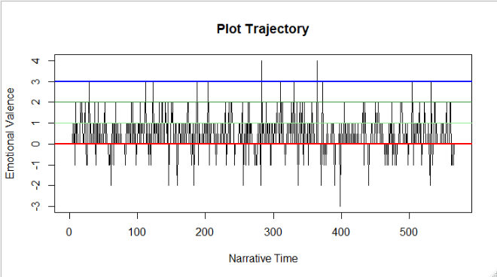

**From the above plat we can say that, he twitted extreme positive words.**

**Analyzing using “bing”**

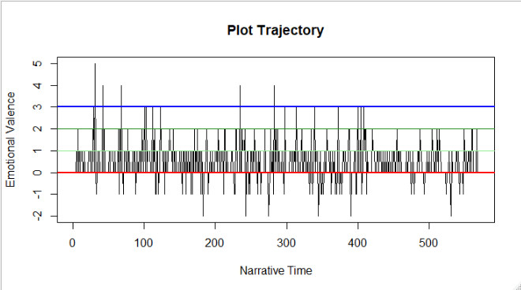

**From the above plot, extreme positive reviews reached up to +5 or else negative reviews only up to -2.**

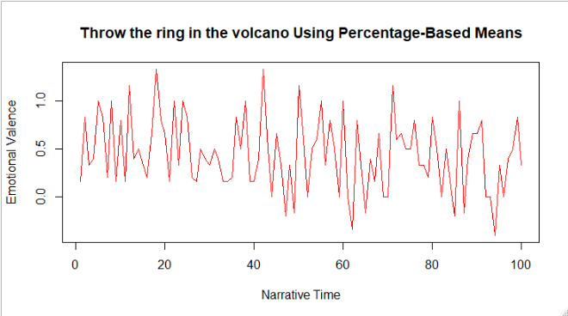

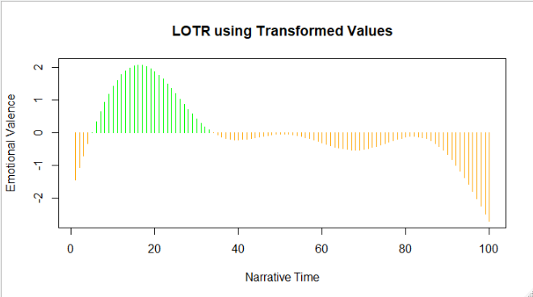

**Emotion Analysis**

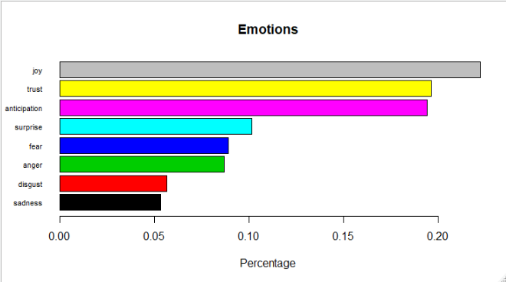

**From the above 8 emotions we can conclude that, Modi’s tweets are most trustworthy.**

**Word Cloud**

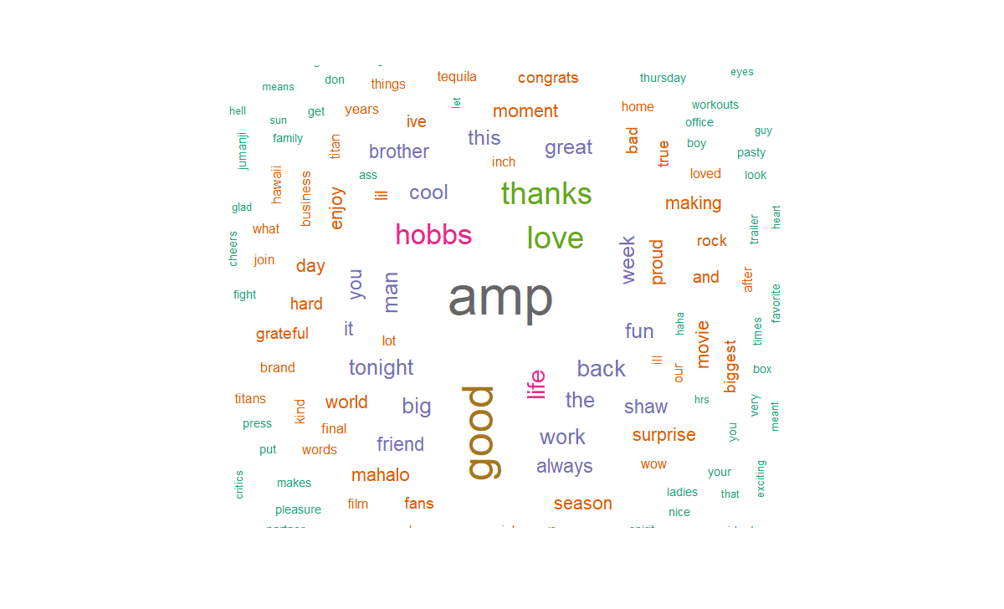

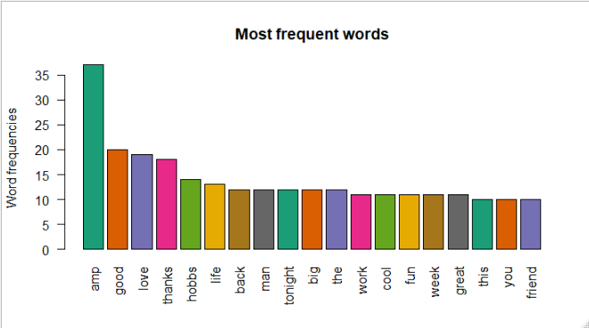

**From the word cloud and bar plot, Modi is loved by people and so he thankful to the folks.**